Field Addresses for All Tournament Locations

Boys Baseball Tournament

Beverly
Kennedy Park
11320 S Western Ave
Chicago, IL 60655
Diamond 5 (Southwest Side of the Park)

Brookfield
9u
Kiwanis Park
8820 Brookfield Ave, Brookfield, IL
Gav Field (Field #8)
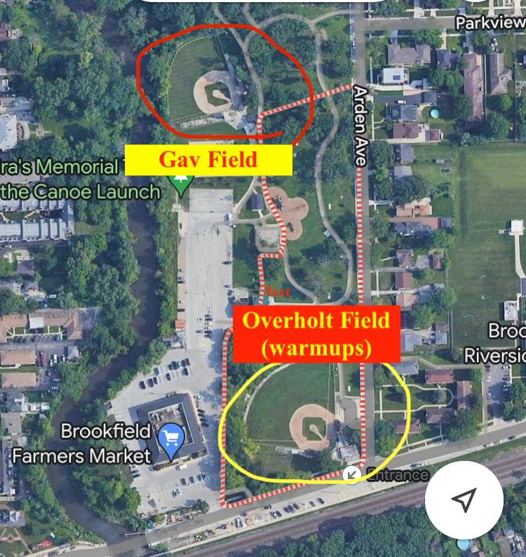

12u
Ehlert Park
4338 Congress Park Ave, Brookfield, IL
Field #2

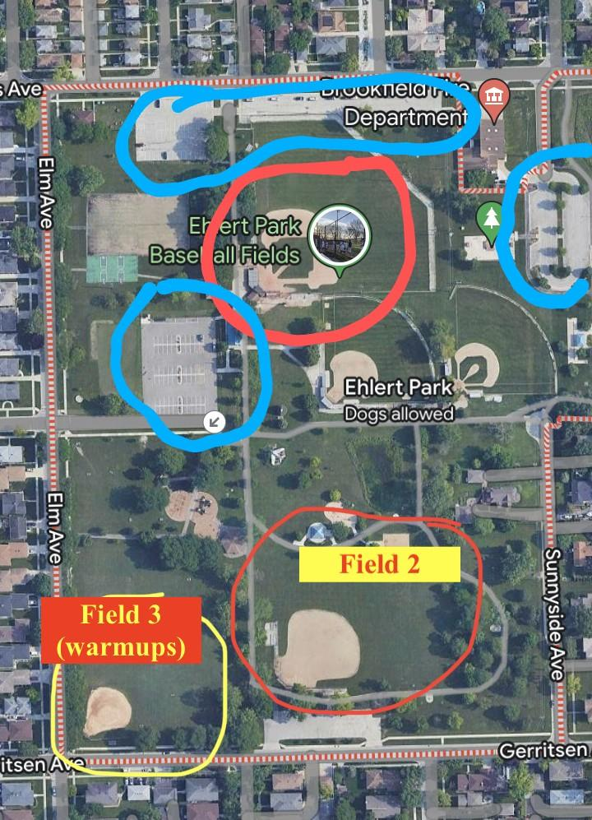

14u
Ehlert Park
4338 Congress Park Ave, Brookfield, IL

Darien
8u
Mark Delay Elementary School
6801 Wilmette Ave
Darien, IL 60561

9u
Eisenhower Jr High School
1410 W 75th Street
Darien, IL 60561

Elmhurst
Berens Park
493 N Oaklawn Ave
Elmhurst, IL 60126

Evergreen Park
9u
Duffy Park
9200 S Millard Ave
Evergreen Park, IL 60805

11u
Norris Field
8930 S California Ave
Evergreen Park, IL 60805

Flossmoor
Flossmoor Park
2523 Flossmoor Road, Flossmoor, IL
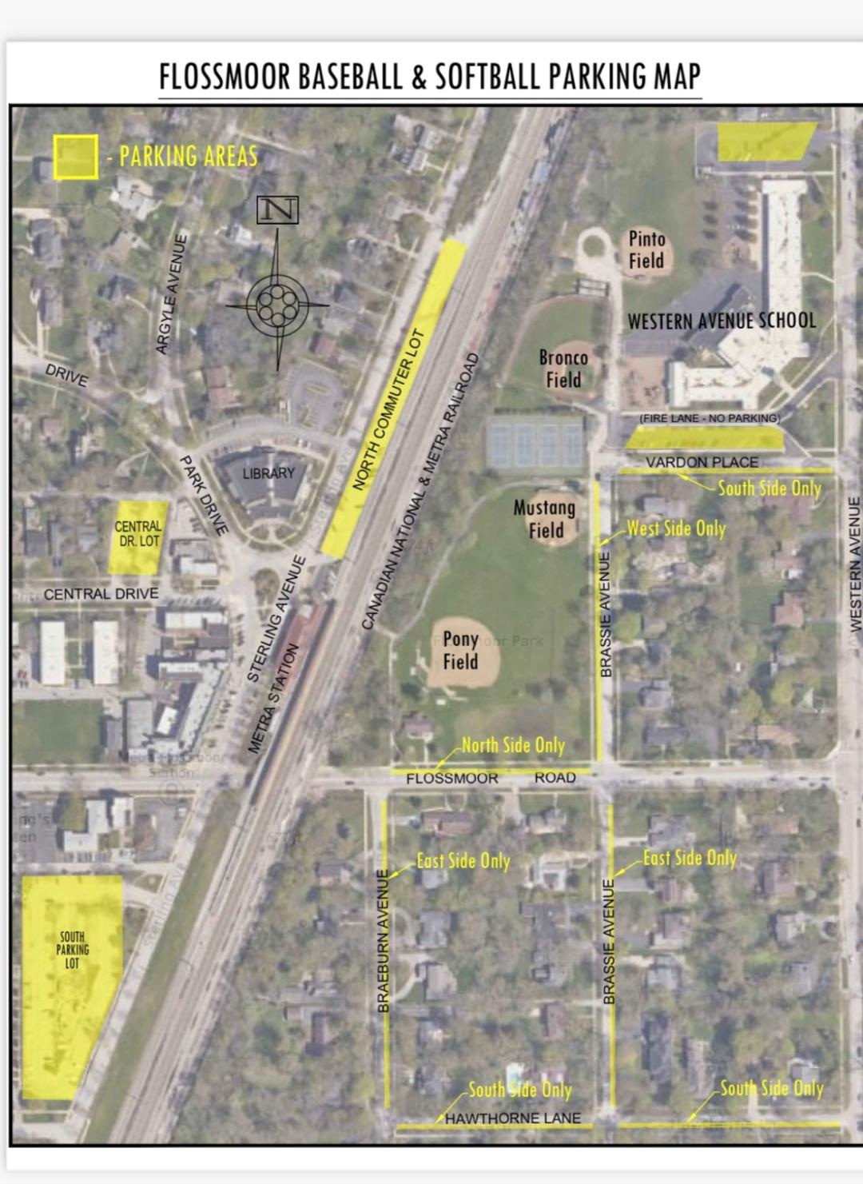
Frankfort Square
Union Creek Park
19900 80th Ave, Tinley Park, IL
8u- Union Creek Field # 3
9u- Union Creek Field #2
12u- Union Creek Field #1

Oak Lawn
Oak Lawn Athletic Complex
Fields are located behind Christ Hospital
Field 4- 8u
Field 3-9u
Field 1- 10u

Romeoville
Village Park
900 W Romeo Rd
Romeoville, IL 60446

Westside
Westside Baseball Field
9400 Oak Park Ave
Oak Lawn, IL 60453

Whiteford
Whiteford Youth Baseball Fields
930 NE Frontage Road
Joliet, IL 60431

Girls Softball Tournament

Bourbonnais
BBYSL Fields
3339 North 1000 West Road, Bourbonnais, IL

Evergreen Park
Circle Park
9719 S Homan Ave
Evergreen Park, IL

Frankfort
8u & 9u
Main Park
400 W Nebraska St, Frankfort, IL 60423

10u & 12u
Jackson Creek Park
22831 S Wolf Road, Frankfort, IL

***Additional Frankfort Notes***
9u Softball is at Main Park on Saturday/Sunday, but at Jackson Creek on Monday

Palos
Palos Power Fields
7607 W College Drive, Palos Heights, IL
(Next to the Palos Heights Public Pool Parking Lot)

