Field Addresses for All Tournament Locations

Boys Baseball Tournament

Brookfield Greyhounds
14u
Ehlert Park
4338 Congress Park Ave, Brookfield, IL

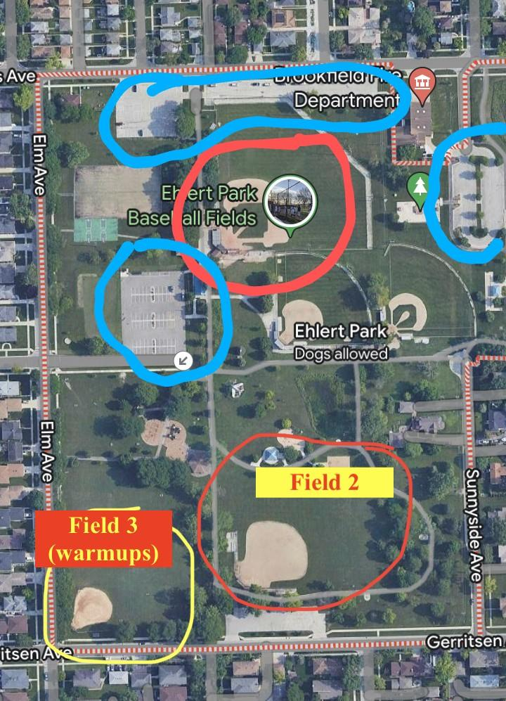

Brookfield Nationals
9u
Kiwanis Park
8820 Brookfield Ave, Brookfield, IL
Gav Field
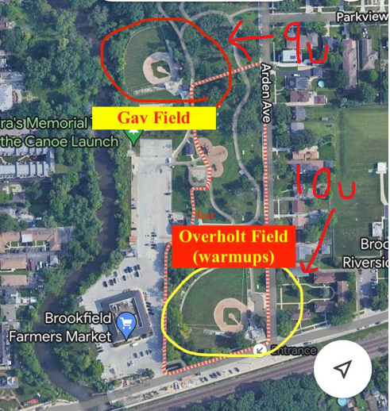

10u
Kiwanis Park
8820 Brookfield Ave, Brookfield, IL
Overholt Field

Darien
8u
Mark Delay Elementary School
6801 Wilmette Ave
Darien, IL 60561

9u
Eisenhower Jr High School
1410 W 75th Street
Darien, IL 60561
West Field

12u
Eisenhower Jr High School
1410 W 75th Street
Darien, IL 60561
East Field

Elmhurst
Berens Park
493 N Oaklawn Ave
Elmhurst, IL 60126

Evergreen Park
Duffy Park
9200 S Millard Ave
Evergreen Park, IL 60805

8u - Duffy Park Southeast Field
9u - Duffy Park Southwest Field
10u - Duffy Park Northeast Field
11u - Duffy Park Northwest Field

Flossmoor
Flossmoor Park
2523 Flossmoor Road, Flossmoor, IL
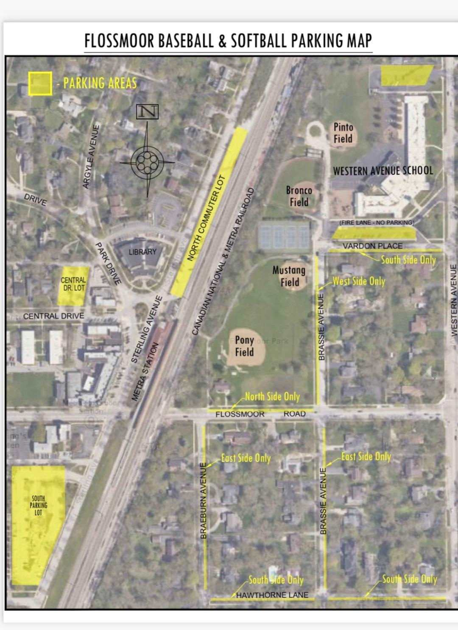

Frankfort Square
Union Creek Park
19900 80th Ave, Tinley Park, IL

La Grange Park
Hanesworth Park
1501 Barnsdale Rd
La Grange Park, IL 60526

Westmont
Veteran’s Memorial Park
55 E Richmond St
Westmont, IL 60559

Westside
Westside Baseball Field
9400 Oak Park Ave
Oak Lawn, IL 60453

Whiteford
Whiteford Youth Baseball Fields
930 NE Frontage Road
Joliet, IL 60431

Girls Softball Tournament

Bourbonnais
BBYSL Complex
3339 North 1000 West Road, Bourbonnais, IL

Evergreen Park

*8u and 9u tournament will be held at Circle Park. 10u tournament will be held at Yukich Park*

Circle Park
9719 S Homan Ave
Evergreen Park, IL

Yukich Park
8900 S Kedzie Ave
Evergreen Park, IL

Palos
Palos Power Fields
7607 W College Drive, Palos Heights, IL
(Next to the Palos Heights Public Pool Parking Lot)

